迁移mysql数据库到oceanbase
安装mariadb并配置密码
yum install mariadb-server
在首次登陆mysql时，一定要注意修改以下内容，否则会出现远程登陆不上，或者本地登陆不上，或者本地登陆进去看不到全部的表的问题。
1、删除mysql数据库中user表里面，用户名为空的行。delete from user where user = '';
2、给root用户设置密码，密码必须是加密的。update user set password = password('123456') where user = 'root';
3、给root用户所有的权限。 grant all privileges on *.* to root@'%' identified by '123456' with grant option;
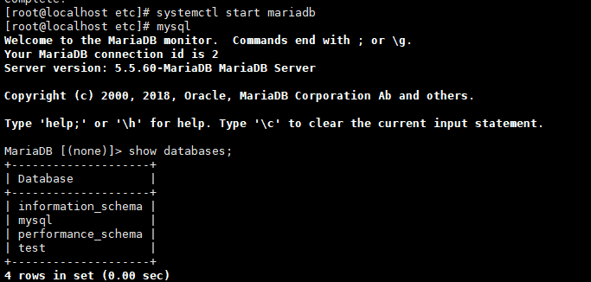
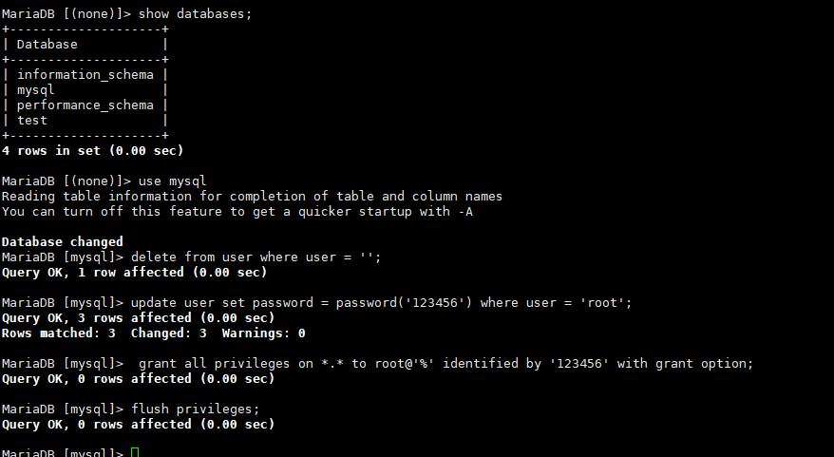

Ob集群创建业务租户
MySQL [oceanbase]> CREATE resource unit 1C1G max_cpu=1, min_cpu=1, max_memory='1G', min_memory='1G', max_iops=10000, min_iops=1000, max_session_num=1000000, max_disk_size='10G';
Query OK, 0 rows affected (0.009 sec)

MySQL [oceanbase]> CREATE resource pool pool_1 unit = '1C1G', unit_num = 1;
Query OK, 0 rows affected (0.021 sec)

MySQL [oceanbase]> create tenant mysql_t1 resource_pool_list=('pool_1'), primary_zone='RANDOM',comment 'mysql tenant/instance', charset='utf8' set ob_tcp_invited_nodes='%', ob_compatibility_mode='mysql';
Query OK, 0 rows affected (1.924 sec)

登陆业务租户创建用户
MySQL [(none)]> alter user root identified by 'root';
Query OK, 0 rows affected (0.052 sec
MySQL [(none)]> grant all privileges on *.* to 'test'@'%' identified by 'test' with grant option;
Query OK, 0 rows affected (0.060 sec)
使用普通用户登陆
[admin@localhost ~]$ obclient -h xxx.xx.153.211 -utest@mysql_t1#obcls01 -P2883 -p -c -A
Enter password:
Welcome to the OceanBase. Commands end with ; or \g.
Your MySQL connection id is 32
Server version: 5.6.25 OceanBase 3.1.2 (r10000392021123010-d4ace121deae5b81d8f0b40afbc4c02705b7fc1d) (Built Dec 30 2021 02:47:29)

Copyright (c) 2000, 2018, Oracle, MariaDB Corporation Ab and others.

Type 'help;' or '\h' for help. Type '\c' to clear the current input statement.

使用mysqldump

模拟数据
创建测试用户
Database changed
MariaDB [mysql]> grant all privileges on *.* to 'test'@'%' identified by 'test' with grant option;
Query OK, 0 rows affected (0.00 sec)

[root@localhost sysbench]# sysbench ./oltp_insert.lua --mysql-host=127.0.0.1 --mysql-port=3306 --mysql-user=test --mysql-password=test --mysql-db=test --table-size=100000 --tables=5 --threads=16 --events=999999999 prepare
sysbench 1.0.20 (using bundled LuaJIT 2.1.0-beta2)

Initializing worker threads...

Creating table 'sbtest1'...
Creating table 'sbtest3'...
Creating table 'sbtest5'...
Creating table 'sbtest4'...
Creating table 'sbtest2'...
Inserting 100000 records into 'sbtest1'
Inserting 100000 records into 'sbtest4'
Inserting 100000 records into 'sbtest3'
Inserting 100000 records into 'sbtest5'
Inserting 100000 records into 'sbtest2'
Creating a secondary index on 'sbtest5'...
Creating a secondary index on 'sbtest3'...
Creating a secondary index on 'sbtest2'...
Creating a secondary index on 'sbtest1'...
Creating a secondary index on 'sbtest4'...
查看表大小
SELECT TABLE_NAME,DATA_LENGTH,INDEX_LENGTH,(DATA_LENGTH+INDEX_LENGTH) as length,TABLE_ROWS,concat(round((DATA_LENGTH+INDEX_LENGTH)/1024/1024,2), 'MB') as total_size
FROM information_schema.TABLES
WHERE TABLE_SCHEMA='test'
order by length desc
;
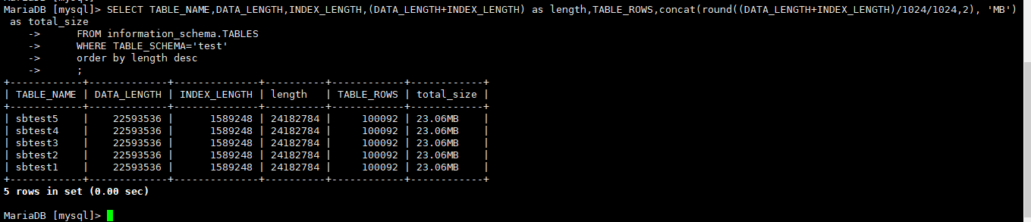

导出数据
导出表结构
[root@localhost ~]# mysqldump -h 127.1 -utest -ptest -d test --compact>testdb.sql
导出数据
[root@localhost ~]# mysqldump -h 127.1 -utest -ptest -t test --compact>testdb_data.sql

导入数据
[admin@localhost ~]$ obclient -h xxx.xx.153.211 -utest@mysql_t1#obcls01 -P2883 -p -c -A
Enter password:
Welcome to the OceanBase. Commands end with ; or \g.
Your MySQL connection id is 32
Server version: 5.6.25 OceanBase 3.1.2 (r10000392021123010-d4ace121deae5b81d8f0b40afbc4c02705b7fc1d) (Built Dec 30 2021 02:47:29)

Copyright (c) 2000, 2018, Oracle, MariaDB Corporation Ab and others.

Type 'help;' or '\h' for help. Type '\c' to clear the current input statement.
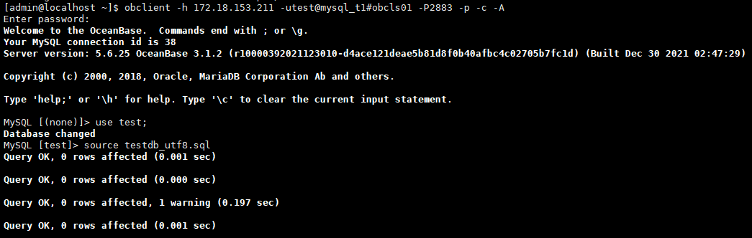
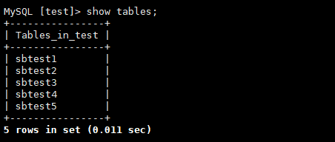

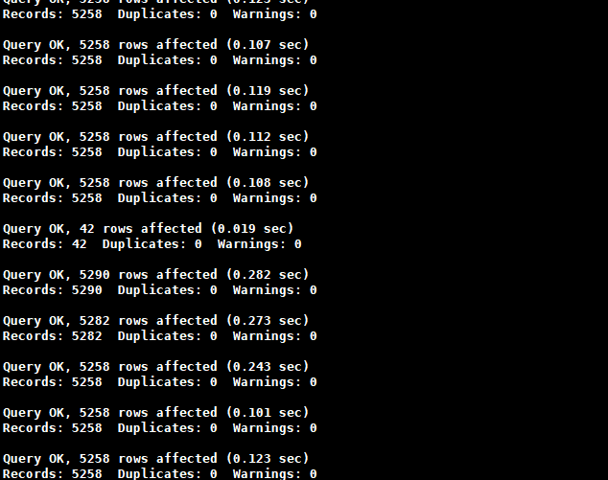

查看数据
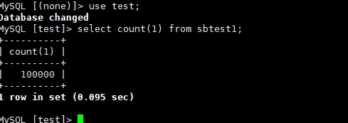

通过datax同步mysql数据

模拟数据
数据库为test1表为test1包括两行数据
MariaDB [(none)]> CREATE DATABASE `test1` DEFAULT CHARACTER SET = utf8mb4 ;
Query OK, 1 row affected (0.00 sec)

MariaDB [(none)]> use test1;
Database changed
MariaDB [test1]> create table test(id int,name varchar(2));
Query OK, 0 rows affected (0.01 sec)
MariaDB [test1]> insert into test values(1,'lu');
Query OK, 1 row affected (0.00 sec)
MariaDB [test1]> commit;
Query OK, 0 rows affected (0.00 sec)
MariaDB [test1]> insert into test values(2,'lu');
Query OK, 1 row affected (0.00 sec)
MariaDB [test1]> commit;
Query OK, 0 rows affected (0.00 sec)

部署datax软件
1) 从http://datax-opensource.oss-cn-hangzhou.aliyuncs.com/datax.tar.gz下载Datax并解压
Cd /home/admin
tar -zxvf datax.tar.gz
2) 删除 plugin 文件夹下的隐藏文件
cd /home/admin/datax/plugin/writer && rm -rf .*
cd /home/admin/datax/plugin/reader && rm -rf .*

生成 mysql 同步至 OceanBase 的配置模板
[root@localhost datax]# python bin/datax.py -r mysqlreader -w oceanbasev10writer > mysql2objob.json

4、修改模板
[root@localhost datax]# python ./bin/datax.py mysql2objob.json

模板配置内容如下
[root@localhost datax]# cat mysql2objob.json
{
"job": {
"content": [
{
"reader": {
"name": "mysqlreader",
"parameter": {
"column": ["id","name"],
"connection": [
{
"jdbcUrl": ["jdbc:mysql://127.0.0.1:3306/test1?useUnicode=true&characterEncoding=utf8"],
"table": ["test"]
}
],
"password": "test",
"username": "test",
"where": ""
}
},
"writer": {
"name": "oceanbasev10writer",
"parameter": {
"column": ["id","name"],
"preSql": [
"truncate table test"
],
"connection": [
{
"jdbcUrl": "||_dsc_ob10_dsc_||obcls01:mysql_t1||_dsc_ob10_dsc_||jdbc:oceanbase://xxx.xx.153.211:2883/test", 集群名：组合名
"table": ["test"]
}
],
"obWriteMode": "insert",
"password": "test",
"username": "test"
}
}
}
],
"setting": {
"speed": {
"channel": 4
}
}
}
}

执行同步
[root@localhost datax]# python ./bin/datax.py mysql2objob.json
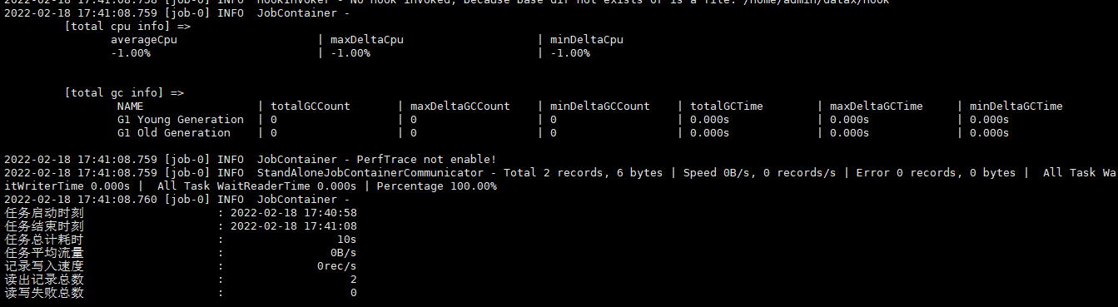

同步日志

同步结果查看
[admin@localhost ~]$ obclient -h xxx.xx.153.211 -utest@mysql_t1#obcls01 -P2883 -p -c –A
