Simon：一台机器上部署OceanBase集群

准备环境
操作系统：centos7.8
磁盘情况
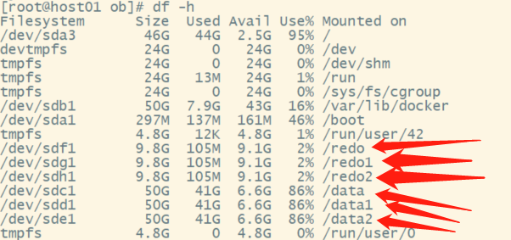

基础配置
创建admin用户并设置密码（所有节点都要设置）：
#useradd -U admin -d /home/admin -s /bin/bash && echo "123" |passwd --stdin admin
#useradd -U admin1 -d /home/admin1 -s /bin/bash && echo "123" |passwd --stdin admin1
#useradd -U admin2 -d /home/admin2 -s /bin/bash && echo "123" |passwd --stdin admin2

更改目录权限：
#chown -R admin.admin /data && chown -R admin.admin /redo && chown -R admin.admin /home/admin
#chown -R admin1.admin /data1 && chown -R admin.admin /redo1 && chown -R admin1.admin /home/admin1
#chown -R admin2.admin /data2 && chown -R admin.admin /redo2 && chown -R admin2.admin /home/admin2

Note:先创建admin用户，后mount挂载/home/admin/ocaeabase 否则创建用户提示家目录存在
配置sudo权限：
# yum remove ntp -y# yum install chrony# vim /etc/chrony.conf
server ntp1.aliyun.com iburst
driftfile /var/lib/chrony/drift
makestep 1.0 3
rtcsync
logdir /var/log/chrony
allow all
stratumweight 0
local stratum 10
# systemctl start chronyd && systemctl enable chronyd && systemctl status chronyd

配置limits.conf（所有目标节点）：
# cat /etc/security/limits.conf |grep ^[^#]
root soft nofile 655350
root hard nofile 655350* soft nofile 655350* hard nofile 655350* soft stack 20480* hard stack 20480* soft nproc 655360* hard nproc 655360* soft core unlimited* hard core unlimited
退出当前会话，重新登录。执行 # ulimit -a，查看配置是否生效：
配置sysctl.conf
# cat /etc/sysctl.conf |grep ^[^#]
fs.aio-max-nr=1048576
net.core.somaxconn = 2048
net.core.netdev_max_backlog = 10000
net.core.rmem_default = 16777216
net.core.wmem_default = 16777216
net.core.rmem_max = 16777216
net.core.wmem_max = 16777216
net.ipv4.ip_local_port_range = 3500 65535
net.ipv4.ip_forward = 0
net.ipv4.conf.default.rp_filter = 1
net.ipv4.conf.default.accept_source_route = 0
net.ipv4.tcp_syncookies = 0
net.ipv4.tcp_rmem = 4096 87380 16777216
net.ipv4.tcp_wmem = 4096 65536 16777216
net.ipv4.tcp_max_syn_backlog = 16384
net.ipv4.tcp_fin_timeout = 15
net.ipv4.tcp_max_syn_backlog = 16384
net.ipv4.tcp_tw_reuse = 1
net.ipv4.tcp_tw_recycle = 1
net.ipv4.tcp_slow_start_after_idle=0
vm.swappiness = 0
vm.min_free_kbytes = 2097152
目录规划：一共三个目录 /home/admin /home/admin1 /home/admin2
/home/admin/oceanbase --obs部署启动目录 RPM包自动创建
/home/admin/oceanbase/ob obs数据总目录 手动创建
/data/ob --obs数据文件实际目录 手动创建连接至数据总目录
/redo/{clog,slog,ilog} --事务日志实际目录 手动创建连接至数据总目录
/home/admin/oceanbase/etc --配置文件 启动时在启动目录自动创建
/home/admin/oceanbase/log --运行日志目录 启动时在启动目录自动创建
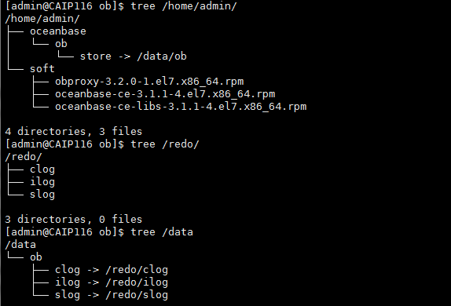
分别配置软连接：admin1 admin2 admin3
$ cd /home/admin/oceanbase/ob
$ ln -sv /data/ob sstable --只能是sstable，其他名字部署会失败
$ ln -sv /redo/clog clog
$ ln -sv /redo/ilog ilog
$ ln -sv /redo/slog slog

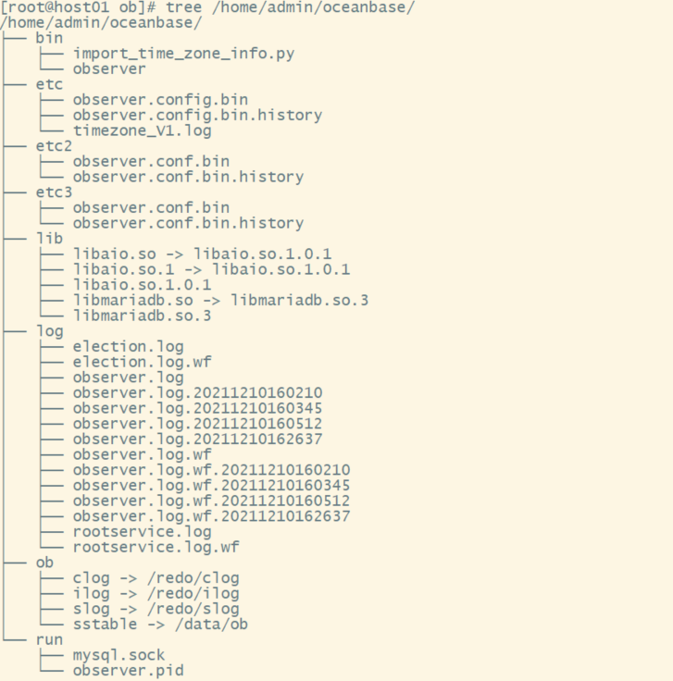

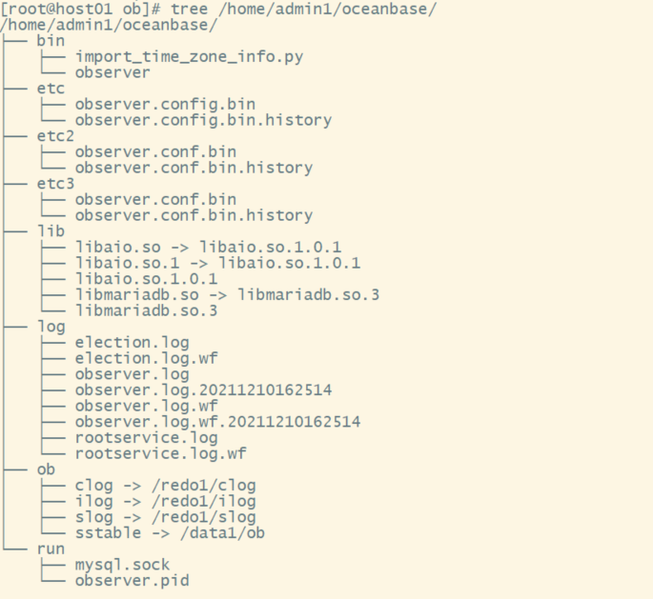
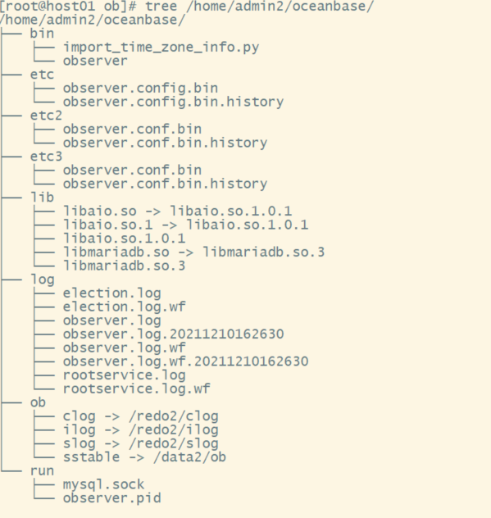

安装部署（切换admin用户）：
$ mkdir ~/soft
软件包下载：
for i in obproxy-3.2.0-1.el7.x86_64.rpm oceanbase-ce-3.1.1-4.el7.x86_64.rpm oceanbase-ce-libs-3.1.1-4.el7.x86_64.rpm libobclient-2.0.0-2.el7.x86_64.rpm obclient-2.0.0-2.el7.x86_64.rpm;do wget https://mirrors.aliyun.com/oceanbase/community/stable/el/7/x86_64/$i;done
目标机安装oceanbase-ce oceanbase-ce-libs libobclient obclient
$ sudo rpm -ivh *.rpm --安装软件包
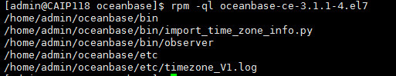
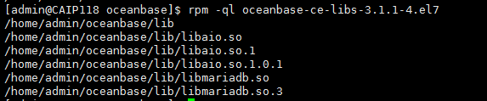
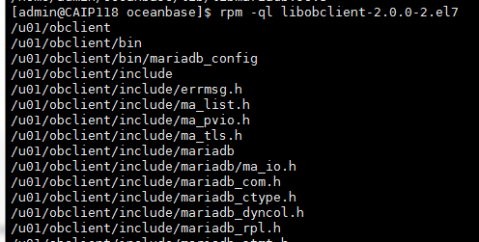
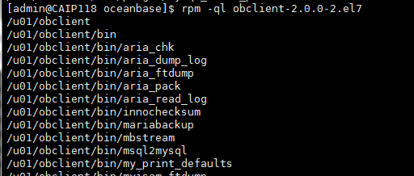
目录机构：
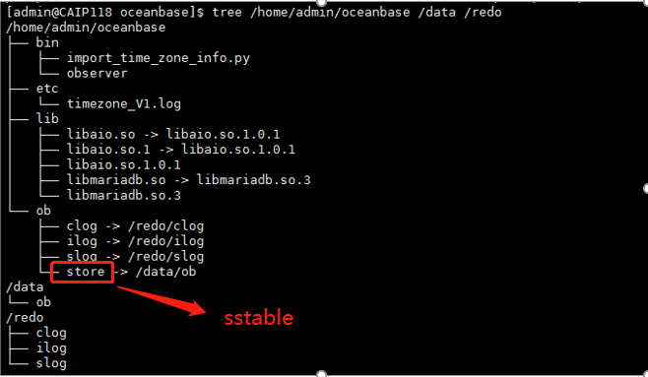
Su - admin
$ echo 'export LD_LIBRARY_PATH=$LD_LIBRARY_PATH:~/oceanbase/lib' >> ~/.bash_profile
$cd ~/oceanbase && bin/observer -i ens37 -p 2881 -P 2882 -z zone1 -d ~/oceanbase/ob -r '192.168.25.199:2882:2881;192.168.25.199:3882:3881;192.168.25.199:4882:4881' -c 202112 -n obdemo -o "memory_limit=8G,__min_full_resource_pool_memory=268435456,system_memory=2G,datafile_size=40G"
$Su - admin1
$ echo 'export LD_LIBRARY_PATH=$LD_LIBRARY_PATH:~/oceanbase/lib' >> ~/.bash_profile
$cd ~/oceanbase && bin/observer -i ens37 -p 3881 -P 3882 -z zone2 -d ~/oceanbase/ob -r '192.168.25.199:2882:2881;192.168.25.199:3882:3881;192.168.25.199:4882:4881' -c 202112 -n obdemo -o "memory_limit=8G,__min_full_resource_pool_memory=268435456,system_memory=2G,datafile_size=40G"
Su - admin
$ echo 'export LD_LIBRARY_PATH=$LD_LIBRARY_PATH:~/oceanbase/lib' >> ~/.bash_profile
$cd ~/oceanbase && bin/observer -i ens37 -p 4881 -P 4882 -z zone3 -d ~/oceanbase/ob -r '192.168.25.199:2882:2881;192.168.25.199:3882:3881;192.168.25.199:4882:4881' -c 202112 -n obdemo -o "memory_limit=8G,__min_full_resource_pool_memory=268435456,system_memory=2G,datafile_size=40G"

验证服务是否启动：
$ ps aux |grep obs$ pidof observer
Note：目标节点配置比较搞，没有输出太多的参数
memory_limit=40G --设置节点总内存的90%system_memory=16G --system_memory大概是memory_limt * 0.4
datafile_size=500G --分配磁盘大小
当 OceanBase 集群三个节点都正常启动，并且监听正常时，连接到任一节点（通过 2881 端口直连），进行自举（bootstrap 集群初始化）操作。 初始密码是空
$ obclient -h 172.20.2.116 -u root -P 2881 -p -c –A
set session ob_query_timeout=1000000000;
ALTER SYSTEM BOOTSTRAP ZONE 'zone1' SERVER '192.168.25.199:2882', ZONE 'zone2' SERVER '192.168.25.199:3882',ZONE 'zone3' SERVER '192.168.25.199:4882';
$ obclient -h 192.168.25.199 -u root@sys -P 2881 -p -c –A -- bootstrap集群初始化成功后可以用系统租户连入
alter user root identified by '123';
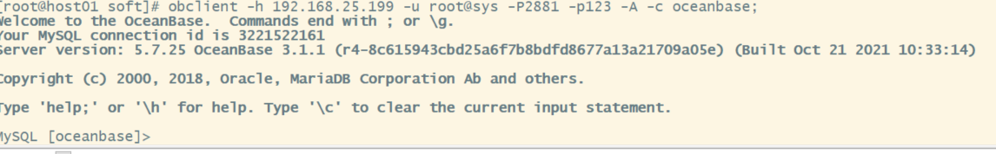
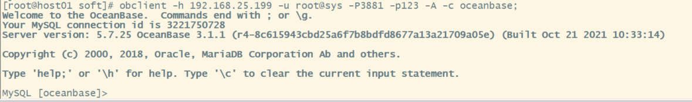
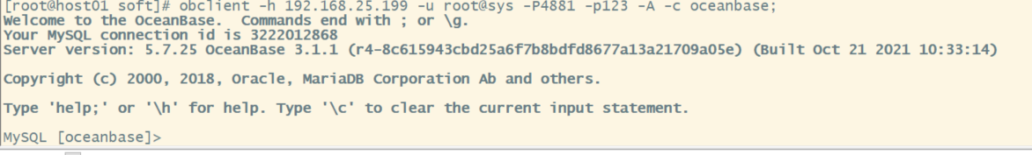

$ obclient -h 172.20.2.116 -u root@sys -P 2881 -psixlens123 -c –A oceanBase
OBPROXY 用户（proxyro）密码默认OBPROXY 连接 OceanBase 集群使用用户 proxyro 。这个用户不存在，需要创建
grant select on oceanbase.* to proxyro identified by 'psixlens123';
查看集群状态：
select * from __all_server;
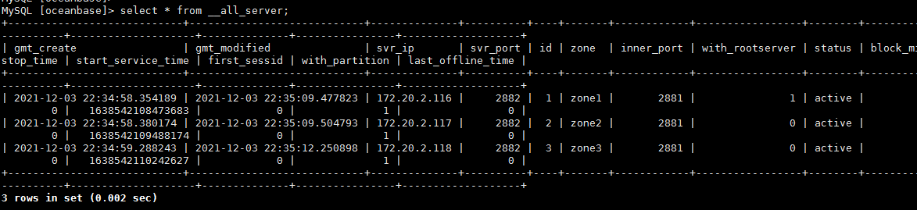
部署obproxy（中控机）：
$ rpm -ivh obproxy-3.2.0-1.el7.x86_64.rpm
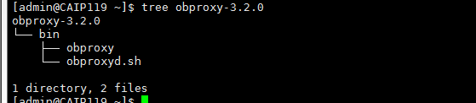
cd ~/obproxy-3.2.0 && bin/obproxy -r "172.20.2.116:2881;172.20.2.117:2881;172.20.2.118:2881" -p 2883 -o "enable_strict_kernel_release=false,enable_cluster_checkout=false,enable_metadb_used=false" -c obdemo
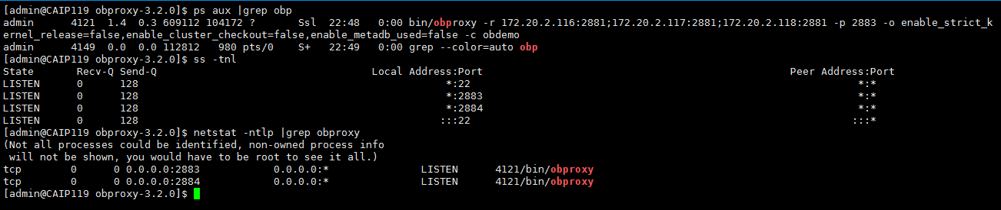
中控机安装obclient，方便测试连接：
$ rpm -ivh libobclient-2.0.0-2.el7.x86_64.rpm obclient-2.0.0-2.el7.x86_64.rpm
$ obclient -h 192.168.25.199-u root@proxysys -P 2883 –p --默认obp密码为空
修改 OBPROXY 用户密码
alter proxyconfig set obproxy_sys_password = '123';
$ obclient -h 192.168.25.199 -u root@proxysys -P 2883 -p123

